Announcements &
Up-Coming Events

March Mission- Willow Women’s Center

Willow Women’s Center is a non-profit organization that provides resources for women facing an unplanned pregnancy. The women receive pregnancy information, medical services, emotional support, and community resources free of charge. For more information, go to their website: https://willowwomenscenter.com
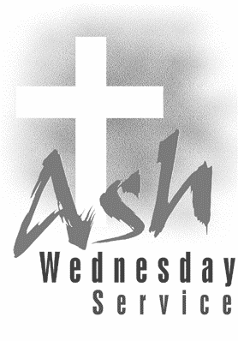

Join us for an Ash Wednesday Service
March 2nd at 6pm

Lenten Bible Study

Join us for “Overcomer” Lenten Bible Study on Sundays from March 13-April 10 at 6pm in the Parlor or via Zoom. If you would like the Zoom link sent to you, please call the office at 724-981-9450 or email us at office@hickoryumc.com.

Lenten Blessing Box Collection

During each week of Lent, we ask you to help stock our Blessing Box if you are able. Any size, type, and brand are appreciated.
Week 1: Breakfast foods (cereal, oatmeal, pop tarts, granola bars)
Week 2: Lunch foods (mac and cheese, chef Boyardee, crackers, tuna, fruit cups, applesauce, snacks)
week 3: Dinner foods (Rice, potatoes, vegetables, soup, Pasta, Pasta Sauce)
week 4: Toiletries (shampoo, toothpaste, toothbrush, toilet paper, deodorant)

